

|  |
| --- |
| Zedra Intranet ZNet  Scope: Analyze current intranet solution  Project Manager: Jack Boolcock  Author: Irimie Razvan  Internal Analysis |
| Version: 1.1  Date: 18.08.2020  Author: Irimie Razvan |



#### About this document

* 1. **Document control:**

|  |  |  |  |
| --- | --- | --- | --- |
| Version | Date | Changed By | Purpose of revision |
| 1.0 | 08.18.2020 | Razvan Irimie | Initial draft |
| 1.1 | 08.20.2020 | Razvan Irimie | Added insights into current intranet solution |
| 1.2 | 08.24.2020 | Razvan Irimie | Completed Gap Analysis |

* 1. **Scope:**

This document aims to analyze and describe the current state of the **Zedra Intranet Portal** as well as to emphasize key improvement points. This document will serve as basis for the **Software Requirement Specification[1]** document which will outline the strategy and will describe functional and non-functional requirements. It covers any

This document does not contain:

* Architectural or technical specifications and considerations.
* Design briefs or any final design/branding elements for **ZNet**
  1. **Objective:**

The objective of this document is:

* To provide an initial assessment of the current Intranet solution
* To provide options on how to address current intranet limitations

#### Automation Account:

#### Overview:

Permissions: DirectoryReader

Sync user profile

https://www.tatvasoft.com/blog/sync-azure-ad-extension-attribute-with-user-profile-service-custom-property-in-office-365/

https://www.sharepointdiary.com/2019/03/sharepoint-online-import-user-profile-property-from-azure-ad-using-powershell.html

Creating Automation account -> RunBook

1. Add module Azure-AD
2. Add module SharePoint Pnp

Connect-pnponline without mfa

(optional) https://www.sharepointdiary.com/2019/08/connect-sharepoint-online-powershell-using-mfa.html

<https://www.sharepointdiary.com/2019/03/connect-pnponline-with-appid-and-appsecret.html>

workaround for providing permisisons

<https://global-sharepoint.com/sharepoint-online/fixed-your-tenant-administrator-has-to-approve-this-app-in-office-365/>

register app

https://zedra365.sharepoint.com/_layouts/15/AppRegNew.aspx

grant app permissions:

https://zedra365-admin.sharepoint.com/_layouts/15/appinv.aspx

<AppPermissionRequests AllowAppOnlyPolicy="true">

<AppPermissionRequest Scope="http://sharepoint/content/tenant" Right="FullControl" />

</AppPermissionRequests>

|  |  |
| --- | --- |
| Client Id: | 38c7a156-99f7-471e-8a52-f00e83128aee |
| Client Secret: | 3Z6FoZpN2RReJz4jc8z5KUMX1rF5EB/oW4mCNzEYQEI= |
| Title: | UserProfileSync |
| App Domain: | localhost |
| Redirect URI: | https://localhost |

#### 

Runbook: ZNetSharePointUserProfileSync

Permissions:

* **Key Sections**
* **Current Features / Office 365 Integration**
  1. **Key Sections:**

This sections is meant to analyze persistent elements across the existing Intranet, such as Navigation, Logo, Banners, Header, Footer as well as general layout and features found on the main pages, Home, Department, Office.

**Navigation:**

* **Current Status:** 
  + - * The current navigation does not offer a good aesthetics by not utilizing space accordingly.
      * The header also contains a cluttered top bar that is not easily decipherable.
      * Lacks user interaction and has low perceived usability.

Fig. 2.1 Current Intranet Header



* **Key Improvements:**
* **Improved UI/UX experience and accessibility.**
* **A persistent navigation across all sites within the Intranet**
* **All menu options are displayed at a glance, rather than having users navigate through a standard hierarchical menu.**
* **Ability to include imagery or symbols for menu options to improve usability and accessibility**

Fig. 2.2 ZNet Intranet Header

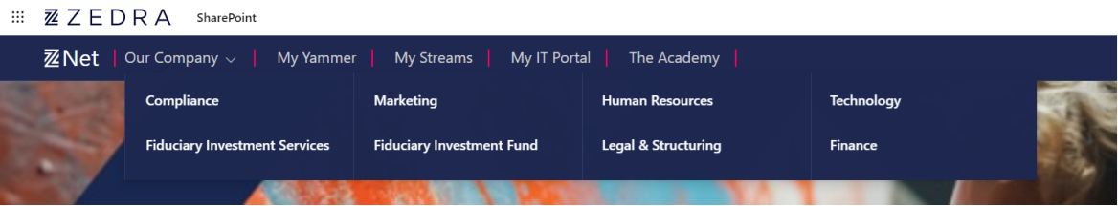

**Footer:**

* **Current Status:**
* No Footer section
* Decreases the accessibility factor by not offering users key information and links within the organization
* **Key Improvements:**
* **Improves the User Experience**
* **Provides engagement at a quick glance**
* **Additional to incorporate branding and corporate identity elements.**

Fig. 2.3 ZNet Intranet Footer Example

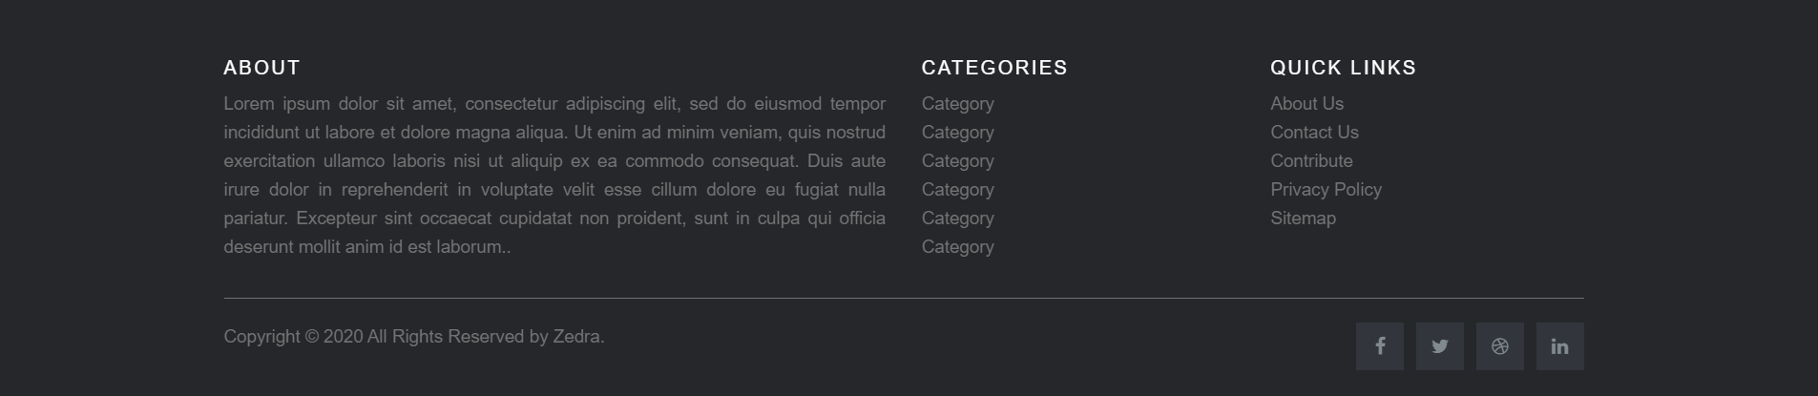

**Departments and My Teams Section:**

* **Current Status:**
* Cluttered, unfocused layout, making it hard for users to navigate through the content
* Lack of a proper focal point,
* Inconsistent visual elements

Lack of user interaction (i.e.: Calendars, Videos)

* **Key Improvements:**
* **Consistent Theming and branding throughout each department or Office site (Site Collection)**
* **Department and office specific homepage which brings with it the features and benefits mentioned below for each Homepage**
* **Ability to share insights, announcements, events for different departments**
* **Design template specific each category (department or office)**

**Homepage:**

* **Current Status:**
* Cluttered, unfocused layout, making it hard for users to navigate through the content
* Lack of a proper focal point,
* Inconsistent visual elements
* Lack of user interaction (i.e.: Calendars, Videos)
* **Key Improvements:**
* **Clear and concise message**
* **Clear layout and focused design, consistent with the whole Office 365 offerings**
* **Several focus points (CEO Message, Banner, etc)**

Fig. 1.2 ZNet Intranet Focus Point. CEO Message and News section

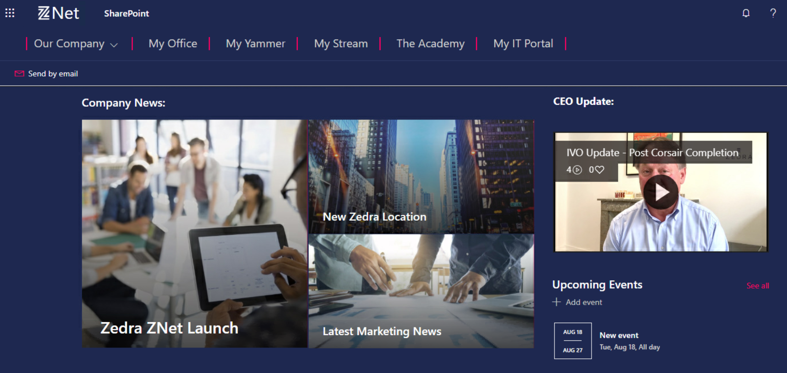

* **Improved user interaction:**
  + 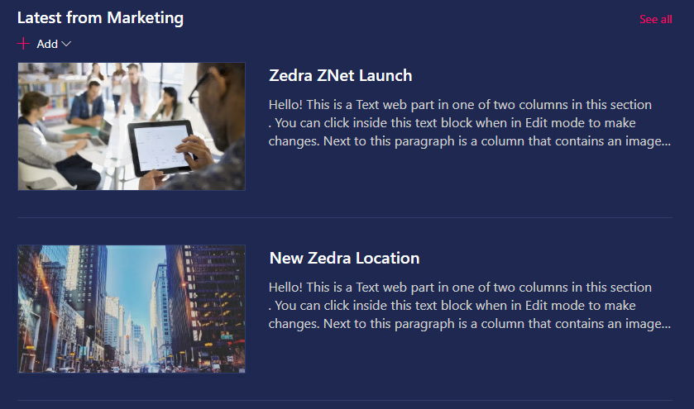**Integrate and easily manage different event Calendars and Events**
  + **Different boards for department announcements**
  + **Seamless integration with Yammer**
  + 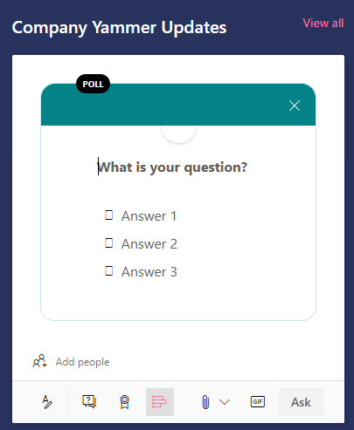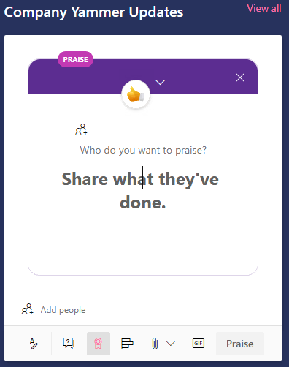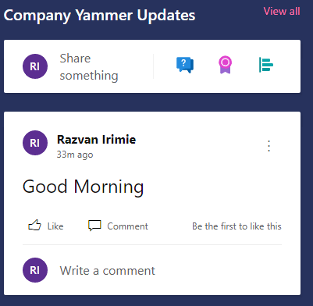**Interactive preview of Yammer discussion boards through which users can view and create new discussions, polls and Q/A boards  
      
      
      
      
      
    Stream:**
    - **Displaying content from different channels or embed a direct video (CEO Message, etc.)**
* **Introducing several CTA (Call to Action) items to assist with user engagement**
* **Introduce proper branding and corporate identity elements.**
* **Visual Gallery / slideshow implementation with proper governance**
  1. **Current Features / Office 365 Integration:**

This sections provides an overview analysis of the features included in the current Intranet and it includes also insights on how these features can be transitioned to the Office 365 ecosystem.

**People Directory:**

* **Current Status:** 
  + - * Direct implementation within Intranet
      * Lack of interaction with other Microsoft offerings, such as Teams, Outlook, etc.
      * Cumbersome UI/UX experience
      * Does not provide a meaningful way of interaction between users
* **Office 365 Integration:**

No longer necessary to have a separate People Directory, as this feature is included within several **Office 365 Offerings**, for different purposes:

* + - * **Integration within Teams:**
        + **The Go-to solution for direct IM collaboration, meetings and calls within Zedra for the future**
        + **Ability to directly chat with users, create collaboration Teams and customize content for each Team**
        + **Ability to search for users and to view organizational chart**
        + **Interaction with Outlook Calendar**
        + **Ability to pull in information from various sources by utilizing out of the box connectors for different services.**
      * **Integration within Yammer:**
        + **Act as a wall for Business and Management as well as a social wall by using**
        + **Social collaboration platform with deep integration with other Office 365 services.**
        + **Perfect for company-wide announcement and social interaction:**

**Company leadership can post updates, request for Feedback and share announcement in an interactive and engaging manner**

* + - * + **Staff can create their own groups either private (social) or open (business)**
        + **Ability to create Q/A boards and Polls**

1. See the **Addendum** sections